|  |  |
| --- | --- |
| Date | **16 November 2022** |
| Team ID | PNT2022TMID37631 |
| Project Name | Natural disaster Intensity Analysis and Classification Using Artificial Intelligence |
|  |  |

Project Structure:

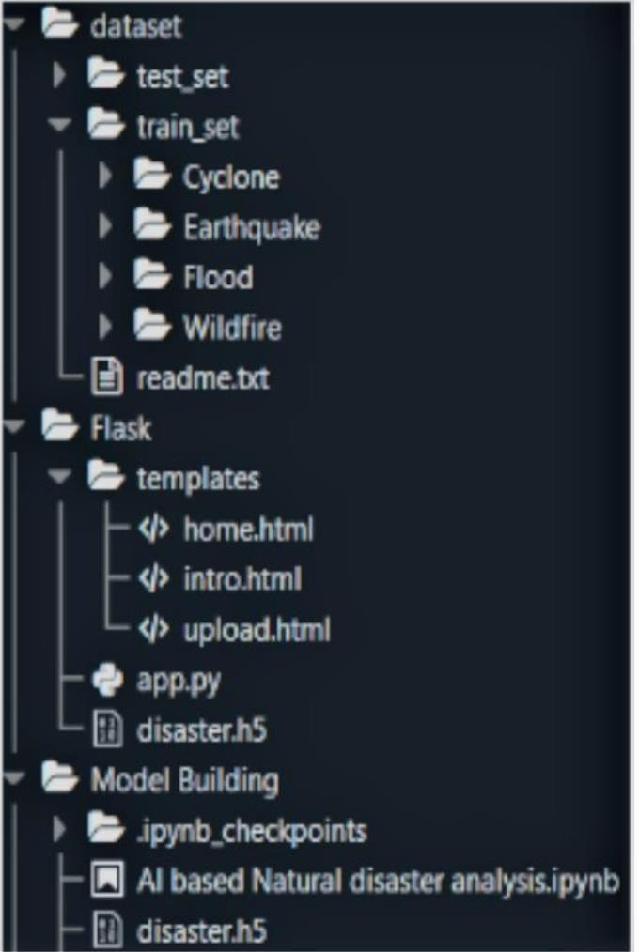

Team Members:

Nandhini G

Aarthi A

Kavitha V

Karthikeyan S